**ShopNest Store Analysis**

1. **Product Rating Analysis:**

* Question Statement: Identify the rating distribution in the ShopNest dataset, showcasing ratings categorized as Excellent, Very Good, Good, Bad, and Very Bad, along with corresponding orders.
* Visualization:

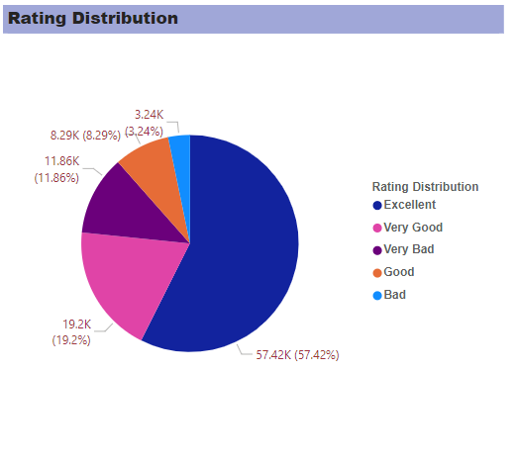

* Explanation:

Based on Visualization it can be seen that products as categorized based on rating.

Excellent is having most amount of rating of 57.42% as compared to everything else. Followed by 19.2% of very Good rating.

1. **Top Categories by number orders:**

* Question Statement: What are the top 10 and bottom 18 most popular product categories in the ShopNest dataset? Please list them based on the number of orders.
* Visualization: 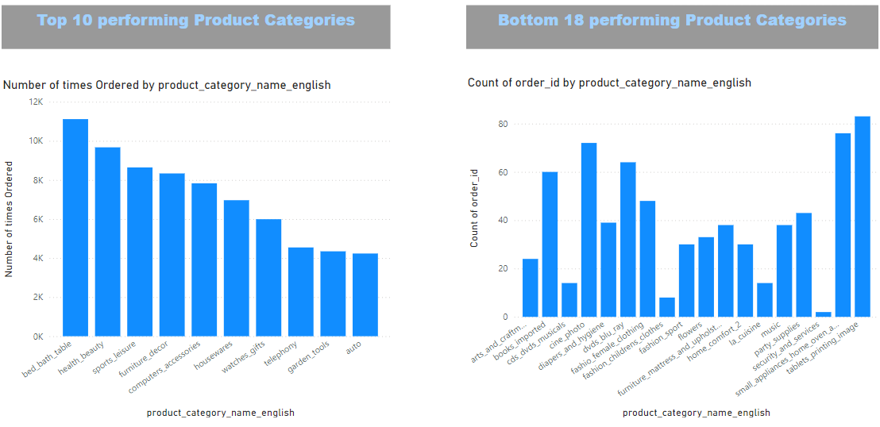
* Explanation:

The top 10 product category of sales are Bed_bath_table, Health_beauty, sports_leisure, Furniture_decor, Computers_accessories, housewares, Watches_gifts, telephony, garden_tools and auto

1. **Total Number of active sellers:**

* Question Statement: List the total number of active sellers by yearly and monthly.
* Visualization:

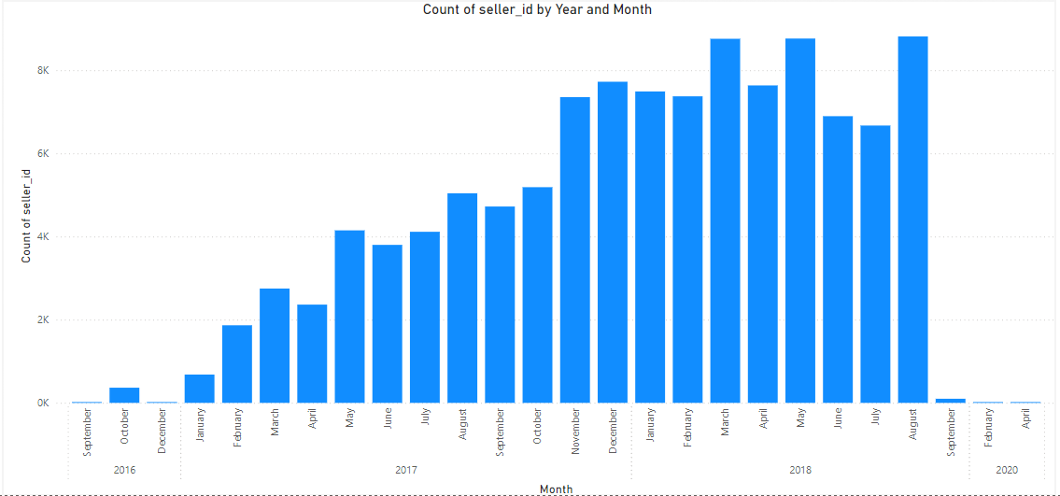

* Explanation:

From the it can be seen that sellers were most active from August 2017 to August of 2018.

There very less active sellers in 2020 and in 2016.

1. **Payment Method Analysis:**

* Question Statement: Analyze the most frequently used payment methods.
* Visualization:

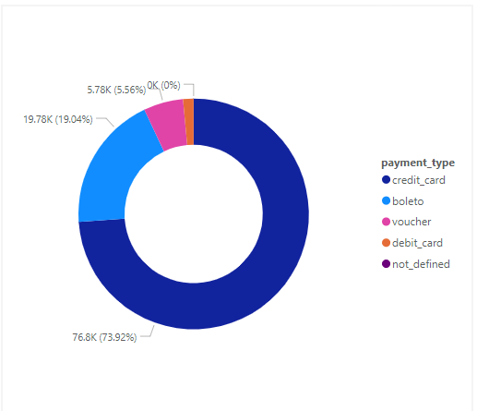

* Explanation:

It can be inferred that payment using credit card takes the higher precedence in comparison with other payment types, it is 73.92% of total payment type count.

Voucher takes the later precedence where the count goes upto 19.04% in comparison to other payment types.

The least contribution is by the debit card type which is 1.53K which takes upto only 1.47%.

1. **Category wise Profit Margin:**

* Question Statement: Identify the product category. wise profit margin using the formula

Hint: (Payment value -price + Freight_value)/payment_value*100 (Rounded to two decimal points).

* Visualization:

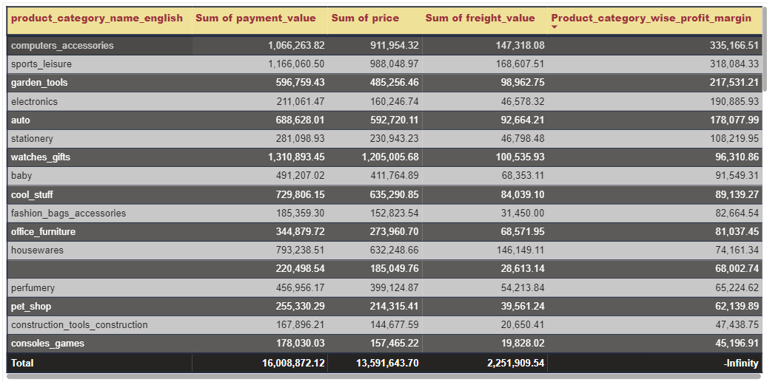

* Explanation:

From the table it can be understood that computer accessories are having maximum profit margin of 335K. Followed by sports leisure by profit margin of 318K.

1. **Payment made by customer by credit card:**

* Question Statement: Determine the monthly payments made by customers using credit cards.
* Visualization:

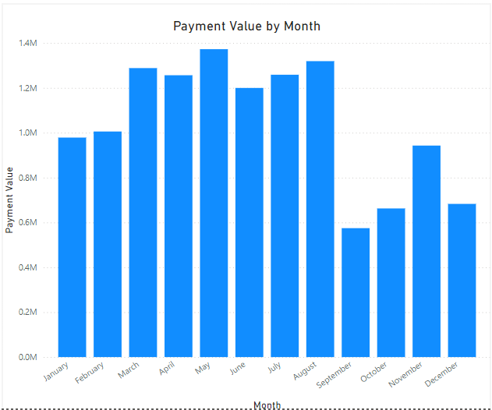

* Explanation:

Looking at above chart of monthly payments made by customers using credit cards.

Most number of credit card payments done in month of May which is around 1.372M followed by August and April with 1.319M and 1.288M respectively.

Least amount of payments are done in month of September with around 574K.

1. **Sellers categorized by city:**

* Question Statement: Identify sellers categorized by city, excluding cities starting with the letters S and B.
* Visualization:

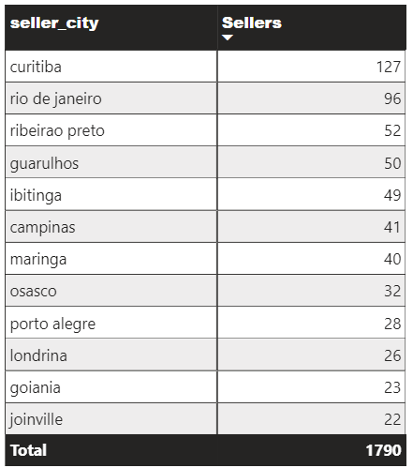

* Explanation:

Most number of sellers are from Curitiba with 127 sellers from the city followed by Rio de Janeiro with 96 sellers. There are total of 1790 sellers available across all the city.

1. **Monthly Comparison of Delayed and On-Time Orders:**

* Question Statement: Create a dynamic visual comparing delayed and on-time orders for each month.
* Visualization:

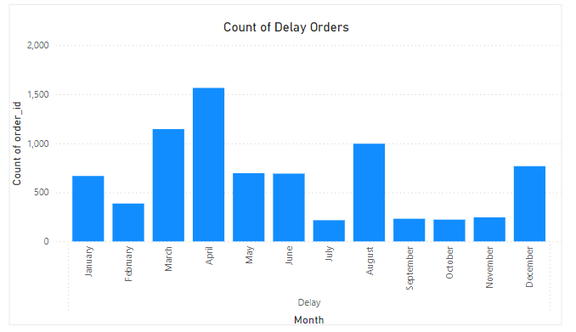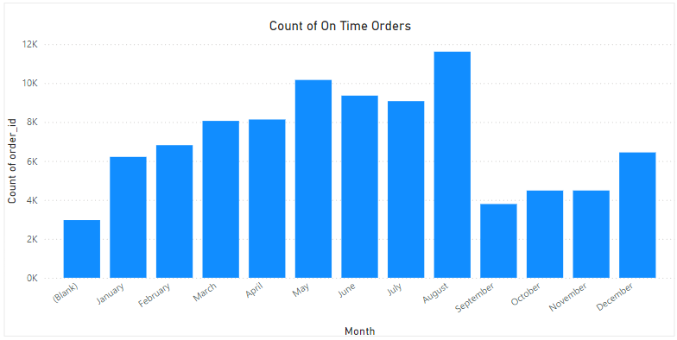

* Explanation:

Using the cross-report drill through functionality we narrowed down two visualizations, the first being Delayed delivers per Month and second being, On-time deliveries per month.

The first image talks about the delayed time orders that occurred in every month, it can be observed that in the month of April the orders considerably were delayed, the count of the orders were ~1.5K, followed by month of March which was ~1K.

The second attached image gives us an idea about on-time deliveries of orders. The month of August observed the most on-time deliveries, the count went ~12K, second highest on-time delivery month was May which was ~10K.